# Lesson 62 单词讲解

1. control n. 控制

控制了什么什么东西

get sth. under control

一直处于控制之中

be under control

失去控制

lose control

不受控制

be out of control

v. 控制control one’s emotion control the budget

1. threaten v. 威胁

threaten A with B 用 B 来威胁 A threaten the village with destruction

threaten to do sth.

The U.S.A. threatened to break off diplomatic relations.

1. authority n. （常用复数）当局

the forest authorities the French authorities

1. quantity n. 量

a large / small quantity of sth. do sth. in large / small quantities

1. root n. 根

take root 生根

Money is a root of all evils. 钱是罪恶的根源

1. patch n. 小片

a patch of … / patches of …

一小片/ 很多片

1. blacken v. 变黑，发暗

the blackened soil

1 control [kən'trəul] n.控制

2 smoke [sməuk] n.烟

3 desolate['desəleit] a.荒凉的

4 threaten ['θretn] v.威胁

5 surrounding [sə'raundiŋ] a.周围的

6 destruction [di'strʌkʃən] n.破坏，毁灭

7 flood [flʌd] n.洪水，水灾

8 authority [ɔ:'θɔriti] n.(常用复数)当局

9 grass-seed ['gra:s'si:d] n.草籽

10 spray [sprei] v.喷撒

11 quantity ['kwɔntəti] n.量

12 root[ru:t] n.根

13 century['sentʃəri] n.世纪

14 patch [pætʃ] n.小片

15 blacken['blækən] v.变黑，发暗

# Lesson 62 课文&语法讲解

本课重点:

过去完成时

过去完成进行时

现在完成时

形式： have/has done

用法：现在的之前 强调事情完成的结果

现在完成进行时

形式： have/has been doing

用法：现在的之前 强调事情进行的过程

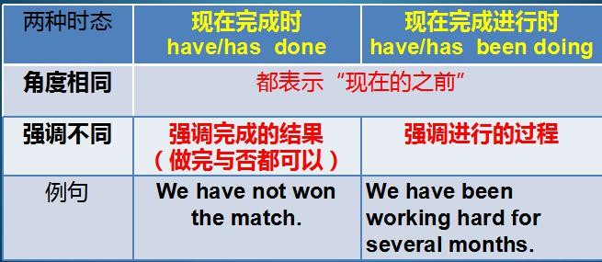

过去完成时

形式： had done

用法：过去的之前 强调事情完成的结果

过去完成进行时

形式： had been doing

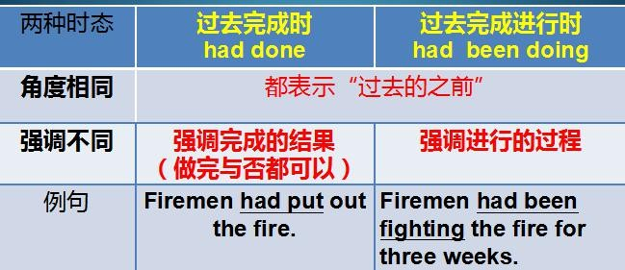用法：过去的之前 强调事情进行的过程

1. Firemen had been fighting the forest for nearly three weeks before they could get it under control.

为什么是过去完成时 看before 后面的句子 could是过去式 所以站在过去的角度看过去 又因为是持续 所以是完成进行时

1. A short time before, great trees (cover) the countryside for miles around.

had covered ?

had been covering ?

1. … smoke still rose up from the warm ground over the desolate hills.

rise rose risen

vi. 上升

The sun rises every day.

1. Winter was coming on and the hills threatened the surrounding villages with destruction, for heavy rain would not only wash away the soil but would cause serious floods as well.

Come on 来

Coming on 继续来

动词ing + on 表示持续 比如driving on 继续开

Winter was coming on

and the hills threatened the surrounding villages with destruction,

for heavy rain would not only wash away the soil but would cause serious floods as well.

* 1. When the fire had at last been put out, the forest authorities ordered several tons of a special type of grass-seed which would grow quickly.

过去完成时的被动 定语从句

The seed was sprayed … in huge quantities by aeroplanes.

Do sth in huge quantities 对应上面的词组do sth. in large / small quantities

1. The planes plant ? seed for nearly a month when it began to rain. had planted ?

had been planting ?

1. The planes had been planting seed for nearly a month when it began to rain.

8.By then … in many places the grass had already taken root.

By then 截止到那个时间

1. In place of the great trees which had been growing there for centuries,

patches of green had begun to appear in the blackened soil.

In place of 替代了 什么什么

# Lesson 62 知识拓展

本课重点:

过去完成时 had + done

过去完成进行时 had been + doing

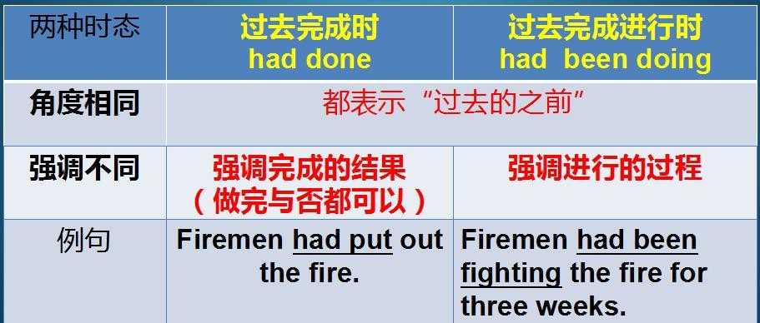

过去完成时／过去完成进行时

Before the tragedy happened,

scientists had been trying to find the cause of the sudden earthquake for a month, but until 1902 nothing had been found.

过去完成时／过去完成进行时

After Tom had won the lottery, everyone who met him asked him what he would do with the money.

Tom had been thinking about the huge amount of money for almost two weeks, but he still didn’ t decide how to spend it.

本课重点:

过去完成时 had + done

过去完成进行时 had been + doing

